|  |
| --- |
| **CHAPTER 3:** ***Exponential and Logistic Functions* (Pages 245 – 267)** |
| **Objectives:** |
| Define exponential functions. |
| Distinguish between growth and decay. |
| Graph an exponential function, showing its initial value and its asymptote. |
| How do you find the initial value of an exponential function? |
| **Essential Questions:** |
| What is the model for exponential growth? What is the model for exponential decay? Can you give an actual example of exponential growth? Can you give an actual example of exponential decay? |
| Define logistic functions as a special type of exponential function. |
| Find the initial value of a logistic function and its 2 asymptotes. |
| Find the inflection point of a logistic function. |
| Model actual situations with exponential and logistic functions. |
| **Technology:** TI-84 plus graphing calculator |

***TUESDAY, 11.12.24***

**Discuss the previously assigned work:**

* Page 257, #58
* Page 256, #49, 50, and Page 257, #61, 66

A Swiss mathematician **Leonhard Euler** originated the **Natural Number *e*. The value of *e* is _____________________, accurate to 5 decimal numbers.**

Leonhard Euler popularized the use of the number ***π, whose value is ________________________, accurate to 5 decimal numbers.***

Both ***e*** and ***π*** are Complex, Real, and Irrational Numbers. An irrational number is a number that cannot be written as a fraction. ***Irrational*** means **Nonfractional**.

This is the hierarchy of the **Complex Number System**.

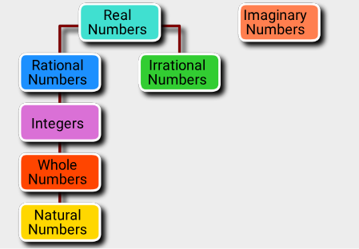

**Class Work/Homework:**

* Graph these two logistic functions:

1. **y = _______20__________**

**2 + 3e0.2 x**

1. **y = _______20__________**

**2 + 3e- 0.2 x**

* **Quick Review** __Page 264 (#1 – 10).
* Page 265 (#19 – 22).
* **Study for a** **Quiz (Graphing a Logistic Function) to be taken on Thursday, 11.14.24.** You may use one page of notes, written on one sheet of 8.5 by 11-inch paper, front and back, to be turned in with your quiz. You will plot and label the initial point, the 2 asymptotes, and the inflection point.

**THURSDAY*, 11.14.24***

**Discuss the previously assigned class work/homework. See above.**

**Quiz (Graphing a Logistic Function**

**Class Work/Homework:** Pages 264, 265, **Exercises** (#1 – 13 odd).

***FRIDAY, 11.15.24* A-DAY, NO CLASS**